**Brooklyn torah gazette**

**For parshas shelach 5779**

Volume 3, Issue 43 (Whole Number 139) 26 Sivan 5779/ June 29, 2019

**Printed L’illuy nishmas Nechama bas R’ Noach, a”h**

For a free subscription, please forward your request to [***keren18@juno.com***](mailto:keren18@juno.com)

**Rav Avigdor Miller on**

**Vacationing at Home**

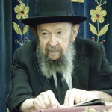

**QUESTION:** My husband loves to learn but I want him to take a vacation. But he tells me that his vacation is to be able to sit and learn. What should I do?

**ANSWER:** You should believe him. When a person is wasting his time making a living and his heart hurts him that he’s not able to learn at that time, and now he has a vacation, so let him sit and learn. Why do you have to travel around - to go to the mountains and to get tired and worn out? And you’ll be uncomfortable there too. At home he has his *beis hamedrash* and his *seforim*; he has all his conveniences at home.

He wants to sit and learn so let him enjoy his life and sit and learn. Some people - I one time had a man in my shul, a wealthy man, so he went for a vacation to the mountains. And in the mountains he decided he needs a vacation from the mountains so he went to Switzerland. These people are never at rest. They think traveling is a good time. Traveling is nothing but discomfort. If you’re home then, *ashrei yoshvei veisecha*, you’re happier at home than anyplace else.

Today wherever you go in the mountains there are ticks in the fields and in the grass. Tick disease; many people are suffering from that today. And accidents happen *chalilah* every summer; things that wouldn’t have happened in the city. Every summer tragedies happen in the country to children and to people; things that wouldn’t happen in the city.

So we say, *ashrei yoshvei vei’secha -*you’re lucky if you stay home. Now, I know you won’t listen to me, but I’m saying it anyhow.

*Reprinted from the May 26, 2019 email of Toras Avigdor (Tape #E-66).*

**Rabbi Yisroel Reisman Initiates Lecture Series**

**On Divrei Hayomim**

**By Daniel Keren**

At last month’s Flatbush Memorial Day Hakhel Yarchei Kallah Event, Rabbi Yisroel Reisman, the Mora D’asra of the Agudath Israel of Madison initiated a new series of shiurim to be delivered on Sefer Divrei Hayomim (the Book of Chronicles) that will continue on subsequent legal holidays when Hakhel organizes similar Yarchei Kallah programs. The title of his first lecture in the new series was appropriately titled “Introducing Divrei Hayomim.”

Rabbi Reisman noted that Divrei Hayomim is the very last sefer or book in Tanach (the Jewish Bible) according to the order arranged by Chazal, our Sages of blessed memory. It is at first glance a collection of historical facts from the beginning of time (Adam Harishon, the ancestor of mankind until Ezra Hasofer [who helped found the Knesset Gedolah, or Great Assembly that helped codify Jewish life in the aftermath of the destruction of the Bayis Rishon, the first holy Temple in Jerusalem more than 2,500 years ago)

Divrei Hayomim was written by Ezra Hasofer (the Scribe) and that fact is mentioned in the Gemora in Mesechta Bava Basra as well as stated by Rashi in his commentary of Divrei Hayomim.

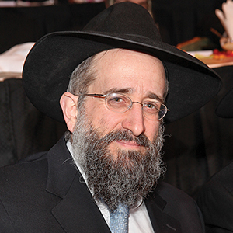

**Rabbi Yisroel Reisman**

**No Jews Lived in Eretz Yisroel for 52 Years**

Following the Churban Bayis Rishon in the year 587 before the Common Era, there were no Jews living in Eretz Yisroel as almost all were exiled to Bavel (Babylonia.) This continued for 52 years until the Persian monarch Cyrus gave permission for Jews to return to the Promised Land and rebuild the Beis Hamikdosh (the Holy Temple in Jerusalem).

However, the non-Jews then living in Eretz Yisroel were upset and they sent back false reports that the Jews were planning on rebelling against the Persians and this resulted in the Persian king retracting his permission and for the next 18 years reconstruction of the Jewish Temple in Yerushalayim was suspended.

Following the death of Achasuverus and the ascension to the Persian throne of his [and Queen Esther’s] son Darius, permission was again given to the Jews to rebuild the Beis Hamikdosh and this holy sanctuary was thus restored.

Rabbi Reisman pointed out that Ezra who accompanied the second group of Jews to return from Bavel to Eretz Yisroel involved himself in the important task of checking into the validity of the Jewishness of those who in those 18 years had returned from Bavel. Unfortunately many of the men had married non-Jewish wives and their children were therefore not Jewish. And from this research of Ezra came the first perakim, chapters of the Book of Chronicles that began with Adam Harishon.

**A Purpose of the Sefer was to Validate the Rule of Dovid Hamelech**

One of the purposes of Divrei Hayomim was to validate the yichus (lineage) of Dovid Hamelech, King David. Perek Aleph (Chapter One) thru Perek Tes (Chapter Nine) is a detailed account of the lineage of not just the Jewish people, but also of all the then known nations of the world. Aleph to Tes takes us from Adam Harishon till Shaul Hamelech, King Saul. Chapter Ten is the story of King Saul and Chapter Eleven begins the story of Dovid Hamelech.

Rabbi Reisman challenged those in attendance at the Memorial Day Hakhel Event with the question of “What is the purpose of Divrei Hayomim?” It was he explained composed by Ezra for the purpose of glorifying the malchus (kingship) of Dovid and our hope for the coming of Moshiach from a descendant of King David.

However, the real message of Divrei Hayomim is to explain the purpose of Hashem’s creation of the world. Do we as Jews believe that all people were created equal. The answer, Rabbi Reisman said is yes. Everyone at the time delineated in the Sefer Divrei Hayomim had the same chance to come close to Hashem. And yet with the free will that everyone was granted by Hakodesh Baruch Hu, it was the Jews who opted to fulfill that unique mission.

In the Book of Chronicles, all of the negative aspects that are related in Sefer Melachim, the Books of Kings regarding Dovid’s kingship are omitted. Those include the accounts of Uri and Basheva, Dovid’s son Avshalom and the battles after the death of Shaul Hamelech of the remnant of Shaul’s family and Dovid.

Rabbi Reisman noted that the Beis Yosef (Rabbi Yosef Karo, the author of the Shulchan Aruch (the Code of Jewish Law) was taught by the Maggid, a special malach who came down from heaven to teach him Kabbalistic concepts, including the point that Sefer Divrei Hayomim contained many great hidden secrets connected to the creation of the world.

**Why Adam Harishon Gave Away 70 Years of His Life**

One such point was that Adam Harishon gave away 70 years of his life in order that Dovid Hamelech [who was destined to die at birth] would be able to live. Why? Had Adam [and his wife Chava] not failed in their unique mission [to not eat from the forbidden fruit tree] all of mankind could have gone straight into Gan Eden [thus initiating the Messianic era.]

But because of Adam’s failure, there was a need for a Dovid Hamelech [who through his own unique righteousness[ would merit that his descendant should become the Moshiach (Redeemer) of the Jewish people bringing salvation to the world and thereby rectifying the initial spiritual error of Adam Harishon.

Therefore it makes sense that Adam Harishon would recognize the necessity of giving away 70 years of his life in order that King David who would otherwise have died in childbirth be allowed to live. For had Adam not failed in his mission, there would not have been a need for Dovid to fulfill his unique mission.

Rabbi Reisman concluded his introduction into Sefer Divrei Hayomim be reflecting that the Book of Chronicles relates a thousand years of Jewish history leading to malchus (the House of) Dovid and this gives us all pause to look into the future of the Jewish people and ponder our own purpose in life – to fulfill the important mission entrusted to us by Hakodesh Baruch Hu to help speed by our own attempts at righteousness the coming of Moshiach tzidkeinu.

*Reprinted from the June 6, 2019 edition of The Flatbush Jewish News.*

**The Shmuz onParshas Shelach**

**Peer Pressure**

**By Rabbi Bentzion Shafier**

**Founder of TheShmuz.com**

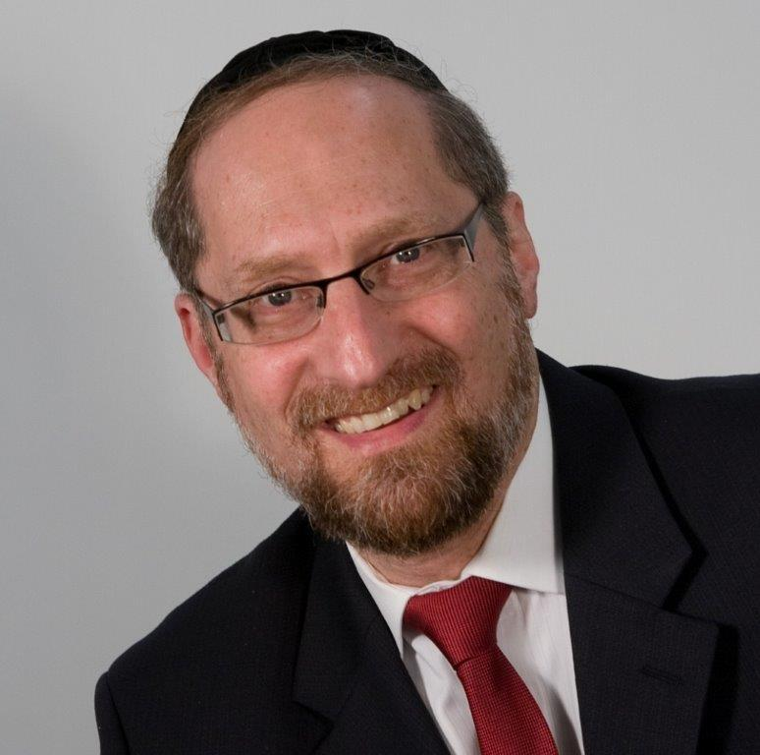

One of most tragic events in the history of our people was the sin of *miraglim* (spies). When we left Mitzraim we were exalted and untouchable, feared by all the nations, respected by the world. Forty-nine days later we gathered at the foot of *Har Sinai* to accept the Torah. The plan was for the Chosen People to then march right into Eretz Yisrael. Had the events transpired as planned, the conquest would have taken root so deeply that we never would have been thrown out --– to this day, we would still be in our land.

But all of this was to change. The course of our nation’s history, as well as that of humanity’s was altered by the report of the spies. “The land of Israel is occupied by giants. There are powerful nations living in fortified cities.” In the minds of the spies, if the Jewish nation were to attack we would have been slaughtered wholesale, man woman and child.

For that reason they attempted to turn the nation against the idea. They came back with fruit from the land to show that just as the produce is gigantic so too are the people—if we attack—we will be lost.

Their goal was to launch a rebellion. Not simply a rebellion against Moshe as the leader- a revolution against HASHEM Himself. The accusation was quite simple—HASHEM is good, but not good enough.

Rashi explains that *Kalev* was aware of the deceit of the group and therefore, he alone went to Chevron, and laid down on the graves of the *Avos* – begging for mercy. “HASHEM please protect me from being dragged into their scheme”

This Rashi is quite difficult to understand. Chalev knew that the *mirgalim* were wrong. He understood that they were rebelling against HASHEM. Why did he need to beg for mercy—he recognized their error?

**It is forbidden to punch your friend**

Imagine that you were to walk into a shul and see, a sign, prominently placed, that read, “It is forbidden to punch your friend with your fist.” You would be shocked. What type of barbarians are these people? And so, you walk over to the *Gabbai* and ask him, “Why in the world do you need to have such a sign”

He answers you, “Well, sometimes things get a bit heated, and it isn’t that uncommon for a man to punch his friend. So we felt the sign would help, sometimes.” At which point you say to yourself, why type of people is it that needs a public warning about something so basic to human decency?

In Slabodka, Poland, in one of the central shuls in town, hung a sign with those words. This was the town that housed one of the most famous Mussar Yeshivas in Pre WWII Europe, yet they needed such a sign. And, so much like we now have signs that read, “It is forbidden to speak during davening”, they had a sign that read, “It is forbidden to punch your friend”.

The reason was because the Jews in Slabodka lived amongst the gentiles of Poland. In a typical Polish house if the woman burnt the potatoes, the man of the house would promptly smack her right across her face. That was normal, expected behavior. While the Jews certainly were different, the surrounding culture affected them, it changed the way that they treated their own wives, and it changed the way they acted towards each other.

**The effects of peer Pressure**

We are much aware of the effects of peer pressure on children. Often more potent than the teaching of the home, and more impacting then the lessons taught in Yeshiva, a child’s peer group will have a profound influence on him.

Amongst children peer pressure can exert an almost magnetic, irresistible force. If the group is doing “it”, then the child will be pulled towards doing it, even if he doesn’t want to, and even if he recognizes it as wrong. The need to belong, the desire to be accepted can be so strong that it can pull him in, almost against his will.

In adults, peer pressure functions differently. It is rare to have a situation where the pull is that strong that a person knows something is wrong but does it anyway. Typically the influence of my friends changes the way that I view things. If the group that I identify with accepts this type of behavior, it becomes OK- this is what we do. I’m not saying it is right, I’m not saying that you will go to the front row of Gan Eden for it—it is just something that *we* do.

**Choose your friends wisely**

This seems to be the answer to this Rashi. Kalev knew the *miraglim* were wrong- he was certain of it. But he was also afraid—these were great men, men very strong in their opinions. They had reasons to believe in their position and Kalev was afraid that they would influence him and he would begin to hear their position.

For that reason he begged for mercy. HASHEM – I see things clearly, now. I understand them. Please don’t let their views influence me. Please don’t let me lose this clarity of thought. Even a man as great as Kalev, dealing with an issue as serve as a national rebellion against HASHEM, was afraid of the influence that his peer group would have upon him- and so he davened for help.

This concept is very relevant to us. The society we live in, the neighborhood we choose, the shul we daven in, and the friends that we choose, affect us. They won’t make us do something that we know is wrong- but they will influence us to view things differently.

The change in attitude isn’t immediate, but if you meet a friend from the old days twenty years later and you took different paths in life, he moved to Eretz Yisrael and you to Brooklyn, while you still share many memories and attitudes, there are real differences in your priorities, attitudes and expectations- that which is normal has changed, that which is acceptable has changed, you have been influenced for the good or the bad by the friends that you chose.

*Reprinted from this week’s website on TheShmuz.com This is an excerpt from the [Shmuz on the Parsha book](https://theshmuz.com/product/shmuz-on-the-parsha-book/).*

**How Could the Meraglim Have Underestimated the Awesome Power of Hashem**

**From the Talks of the Lubavitcher Rebbe**

**Rabbi Menachem Mendel Schneerson, Zt”l**

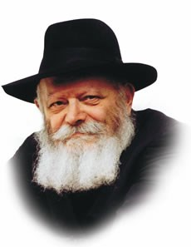

This week's Torah portion, Shelach, contains the account of the twelve spies sent to scout out the land of Israel. Upon their return they announced, "We will not be able to go against the people, for they are stronger than we--mimenu."

Our Sages explain that the Hebrew word "mimenu" may also be interpreted "than him"--than Him! The spies insisted that the inhabitants of Canaan, as it was called, were even more powerful than G-d, Who had promised the land to the Jews.

How could they have made such a statement? All of the twelve spies were men of distinction and piety. Furthermore, the entire Jewish people had just witnessed the greatest open miracles--the exodus from Egypt, the splitting of the Red Sea and the manna falling from the sky. Why wasn't the spies' report simply discounted, instead of being given such credence?

When the spies insisted that the Land was too well fortified to be conquered, Calev stood up and calmed the people. "Don't worry," he insisted. "The same G-d who performed all these miracles for us will continue to guard His people. Let us go up at once, without fear!"

"But," countered the spies, "there we saw the nefilim, the sons of Anak!"

Who were these nefilim, that their mention threw fear into the hearts of the Jews? The great commentator, Rashi, explains that the nefilim were people of gigantic stature, descendents of two angels who had descended to earth many years before during the generation of Enosh. Their very name--"nefilim"--attests to their descent, from the root word meaning "to fall."

Yes, conceded the spies, G-d is certainly more powerful than mere mortals. But can G-d prevail against the nefilim and their higher level of spirituality? The nefilim had even survived the great flood which destroyed the rest of the world. These two angels, who came down into the world with the best and holiest of intentions, were unable to withstand the lure of the material world. They and their descendents ended up degraded and debased. If angels, the spies contended, have failed, how much more so will we if we even attempt to conquer the Land. Let us simply reject the material world and remain in the wilderness!

To this, two of the spies, Joshua and Calev, replied, "No, this is not G-d's plan. G-d wants us to live in the physical world, performing physical mitzvot. 'Do not fear...for G-d is with us'." Angels may not be equipped to deal with this world, but we are even higher than the angels, for we possess a G-dly soul in a corporeal body.

We have the power to fuse the physical with the spiritual, by performing concrete mitzvot which bring holiness into the world and make it a dwelling place for G-d. Thus, we can withstand any negative force, not only emerging triumphant, but transforming those very forces into instruments of good.

*Reprinted from the Parashat Shelach 5753/1993 edition of L’Chaim Weekly (Issue #263), a publication of the Lubavitch Youth Organization in Brooklyn, NY.*

**Rabbi Berel Wein on**

**Parashat Shlach**

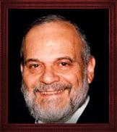

Much has been written and taught regarding the motives of the leaders of Israel, those who Moshe sent to spy out the land of Israel in advance of the Jewish people entering their homeland. After all the explanations, it remains a baffling mystery as to how such great people could have been so wrong on such an important issue. Just as they were able to convince an entire generation to believe as they did, we have found that over the centuries of human history, there have been many instances of such types of situations.

Sometimes these matters are treated as being a symptom of mass hysteria. In the Middle Ages there were many such instances when people were led to believe in the false narratives of leaders, some of whom were even sincere in spreading these narratives.

There was a derisive expression in Yiddish that stated that “the masses of the general public are always fools and ignoramuses.” This is a rather harsh assessment and in a democratic society such as ours, which is allegedly run by and subject to the will of the masses, it does not register favorably in our ears.

Though that assessment of public opinion and belief may be too broad, there is certainly more than a kernel of truth in that saying. And the reaction of the Jewish people to the false narrative stated by the spies who visited Israel, serves as a bitter and eternal reminder of human folly. Such instances are not subject to rational explanation, but they are omnipresent throughout the story of human existence on this planet.

The question always arises as to how to prevent such suicidal mistakes from occurring in Jewish society. Over the past century masses of Jews allowed themselves to be persuaded by false narratives, as was the case with the spies in the desert, resulting in death and disaster. Millions of Jews followed the red flag of Marxism, in all its various forms, only to be devoured by the very beast that they had nurtured.

Others searched for new forms of Judaism they felt would be relevant to their children and to future generations. After all we were in a different world and a different society than that of our ancestors. The old Judaism would somehow prove to be irrelevant and doomed. But just the opposite has seemingly occurred. While all the forms of new, modern and progressive Judaism are teetering on the verge of extinction, the old irrelevant Judaism has revitalized itself and inspired generations with its eternal truths and values granted at Mount Sinai.

The Jewish people traditionally are hasty people. New ideas capture them and to a certain extent, cause a type of mass hysteria that blindsides them. Yet, it is also within our nature, by tradition and history, to be a skeptical people. We should never lose that healthy skepticism when dealing with issues, problems and the possibility of solutions in our current society.

*Reprinted from this week’s website of Rabbiwein.com*

Who's Who?

**The Prophet Ezekiel/**

**Navi Yechezkel**

The prophet Ezekiel (3332-3354) was one of the greatest leaders of the Babylonian exile period. Born of a priestly family in Jerusalem, he was amongst the first of the exiles to Babylonia by King Nebuchadnezzar.

Ezekiel prophesied the destruction of the First Temple and promised his brethren that they would return to the Holy Land. Perhaps his most famous prophecy is that of the Valley of Dry Bones, when he saw that the piles of dried bones rose and were vivified by G-d.

In this way, he reassured his fellow Jews that Israel would enjoy new life and glory after the destruction.

*Reprinted from the Parashat Shelach 5753/1993 edition of L’Chaim Weekly (Issue #263), a publication of the Lubavitch Youth Organization in Brooklyn, NY.*

**Haste Makes Waste**

**By Rabbi Moshe Meir Weiss**

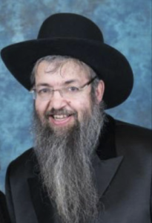

Once again, as in the previous two columns, I’d like to share with you another piece of sage advice from the ancient book of wisdom, Orchos Chaim l’HaRosh. The Rosh teaches us to consider the consequences of any course of action before embarking upon it and he eloquently adds the verse , “V’hachochom einov b’rosho – And the wise man has his eyes in his head.”

At first glance, this seems to be an absurdity.  Everyone has their eyes in their head; it’s not solely the anatomy of one who is wise. But, here is what the Rosh means. Most people react immediately to what they see. The wise person responds to what he thinks about what he saw. So it is only the man of wisdom whose eyes are in their head. The Rosh advises us to take this precaution, not be hasty with our reactions.

When Yaakov was on his deathbed, he told Reuven, “You were the first of my strength and as such you were slated to have both the monarchy and the priesthood. However, ‘Pachas k’mayim, al toser – You were hasty like water,’ and therefore you will not excel.” Just like if a dam ruptures, the water does not ponder whether it should rush out and cause a flood. Rather it bursts out without any concern. So too, since Reuven acted impetuously, he lost all privileges of leadership.

The Rosh is guiding us to always consider the consequences of our actions before making a move. This is the trait of the wise. As it says, Eiza hu chacham? Haroeh es hanolad – Who is the wise man? He who can see the results of his actions.” The fool behaves according to his instincts and chooses the path of immediate gratification.

The Rosh cautions us not to be rash but rather to look before we leap.  So, for example, when couples argue, one of the spouses can say something that will ‘win’ the fight but then he will be stuck with the ‘loser’ the entire evening.  Not a pleasant prospect.  With a modicum of foresight, one can react in a more conciliatory manner and save a nighttime of unhappiness.

Similarly, a parent might scream at a child in frustration and, while the ability to vent affords temporary relief, the loss of the child’s respect or the damage to the tranquility of the home can have long lasting detrimental effects.  As well, a nasty retort to a friend can give one a fleeting sense of relief but the damage of such a comment will linger in his colleague’s memory banks for decades.

So too, in the financial arena, hasty risks can embroil one in years of regret. In public school, they do a drill with kindergarten children. They give them a choice of three M&Ms now or a handful a week from now. Most children opt for the immediately available three. They are not able to look ahead.

Successful life in Yiddishkeit is all about considering the consequences.  Lashon hara leads to Gehenom. Giving away our hard earned money, to a charitable cause, leads to Gan Eden. Choosing a spouse solely because she has a beautiful face,or because he has a bulging financial portfolio, is possible recipe for marital disaster.  Thus, we should try to train ourselves to think before we speak and to consider the consequences before we react.  If we are retorting and responding in anger or in a bad mood, it is oh so true that “Haste makes waste.”

Perhaps this is one of the reasons that the Torah defines the location of the Teffilen on one’s head as, “Ltotafos bein einecha- Frontlets between the eyes”. Of course we know this means that this is on the area of the front of the head that is parallel to between the eyes. Why does the Torah describes the location as between the eyes? Perhaps it is teaching us that when we see with our eyes we should think with our head!

As we get in the habit of “seeing with the eyes in our head,” we will find that soon it will become second nature for us to consider our options carefully, especially before any important endeavor.  In the merit of doing so, may Hashem bless us with long life, good health, and everything wonderful.

*Reprinted from the June 6, 2916 website of Matzav.com*

**The First Rebbe of Bobov: Part Two**

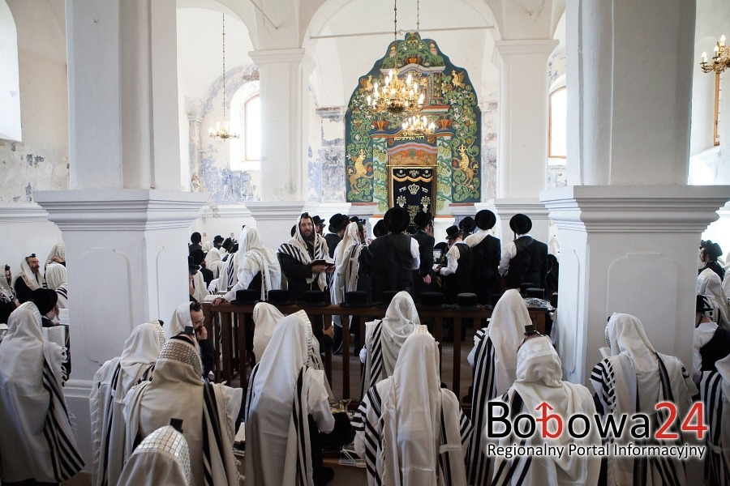

**Many Bobover chassidim returning to visit the town of Bobov in Poland.**

At age 18, R’ Shlomo Halberstam was appointed by his grandfather, R’ Chaim of Sanz, to become the Rav of Bokovosk. In a parting blessing, R’ Chaim stated that he could not bless R’ Shlomo with anything more than he already possessed. He only blessed him that all of his offspring resemble him.

During R’ Shlomo’s initial years in Bokovosk, he did not merit living offspring and suffered many tribulations. He went to pour out his heart to R’ Chaim, and thereafter he merited one son and one daughter.

After serving ten years in Bokovosk, R’ Shlomo became the Chassidic Rav in Ushpitizin, which lay on the border of Poland and Germany. R’ Shlomo immediately set to the task of increasing the Torah observance in Ushpitzin and succeeded in transforming it into a spiritually rich and highly observant city.

Only a few years later, R’ Shlomo was called to leave Ushpitzin to serve as Rav in Vishnitza, where many great Torah sages previously served as Rav, such as the Boruch Taam (father-in-law of R’ Chaim of Sanz) and many others.

In Vishnitza, a new chapter opened in R’ Shlomo’s life. There, many chassidim began to flock to R’ Shlomo, looking to him as their leader and Rebbe. He gained renown as a Poseik as well. R’ Shlomo established a yeshivah for older boys. Thanks to his untiring efforts, Vishnitza became a significant metropolis of Torah and chassidus.

R’ Shlomo’s thorough and deep knowledge in all segments of the Torah stood him in good stead when he established the yeshivah in Vishnitza. Outstanding boys from Vishnitza and the surrounding areas were drawn to him. R’ Shlomo invested tremendous efforts and strength into guiding his students.

He gave a daily shiur and on Friday nights, he learned with them straight until daybreak. R’ Shlomo also assured that each student was respectably provided with his physical needs. He personally collected funds and often went into debt to provide for his students. He put his own and his family’s needs second to those of his students, giving everything to them.

His rebbitzen willingly sacrificed for the students, living in poverty, even giving her wedding jewelry as collateral for loans. Though he humbly denied it, R’ Shlomo was indeed imbued with Ruach HaKodesh, which manifested itself on many occasions.

In the town of Bobov, a wealthy man, R’ Zusia, experienced several financial setbacks and lost his entire fortune. Unable to accept his poverty, he became severely depressed, living the life of a recluse. One Rosh Chodesh, R’ Shlomo, who lived in Vishnitza at the time, asked some of his students to bring R’ Zusia to the se’udah held in honor of the day. They returned without him; he had refused to come.

R’ Shlomo sent a second group, who also came back unsuccessful. Finally R’ Shlomo sent a third party with a message for R’ Zusia: If he still refused to come, R’ Shlomo would send enough young men to bring him to the tish by force. R’ Zusia agreed to come, but asked that they should allow him to come on his own. When R’ Zusia entered a few minutes later and seated himself in the back, R’ Shlomo told the following story: Chassidim of R’ Elimelech of Lizhensk were once traveling to see their rebbe. On the way, they stopped at an inn, where a group of gentiles were celebrating a wedding.

Ignoring the wild partying, the Jews retired to their rooms. The inebriated celebrants decided to amuse themselves at the expense of the Jewish travelers. They began beating the men who were sleeping closest to the door. When they tired of this entertainment, they returned to their drinking, leaving the bruised men to tend to their injuries.

Soon the drunken men returned and began inflicting more wounds on the Jews lying near the door. When they left, one of the men sleeping near the wall offered to switch places with those near the door so that they should not have to withstand any future beatings.

When the drunkards returned yet again, one of them cried, “We’ve been beating the same ones the whole time! Let’s get the Jews lying near the wall now!” – and so they did. When the travelers returned home and related to R’ Elimelech what had befallen them, he remarked, “From this incident we learn three things: First, they don’t hit the whole night. Second, don’t attempt to improve your lot. Third, if you do try to improve the situation, you’ll only make it worse.”

R’ Shlomo repeated the words of R’ Elimelech with great emotion several times, “They don’t hit the whole night; don’t try to improve your lot; if you do try to improve it, it will only be worse….”

Years later, R’ Zusia emigrated to Eretz Yisroel. Before he left, he took leave of R’ Benzion Halberstam, then the Rebbe of Bobov. He told him, “That morning when your father demanded that I come, I had reached a point where I could no longer cope with my situation; I had decided to commit suicide. I had bought a small bottle of poison, and was ready to use it when the Rebbe forced me to come.

He must have sensed with Ruach HaKodesh what I was feeling. When I heard him say those words from R’ Elimelech over and over, I realized that he was warning me not to be foolish. When I came home, I poured out the poison.”

His heart overflowed with love for his fellow Jews. A chassid once asked R’ Shlomo to pray for his daughter who was critically ill. A while later, R’ Shlomo expressed surprise that this chassid did not inform him whether or not his daughter recovered. He sent a message to the chassid stating that he was perturbed at not being informed of his daughter’s condition, for “I yearn to hear good tiding from you and all of Klal Yisroel.”

R’ Shlomo would elaborate on the mitzvah of כמוך לרעיך ואהבת – loving one’s fellow as you love yourself: How is it possible to attain such a level? If one’s friend, for example, was pricked by a needle, how could one’s own skin hurt as if the needle had been stuck into him?

Just as with any mitzvah, one must do his utmost to fulfill it, and he will then receive Heavenly assistance to complete the mitzvah. As the pasuk states, 'ה אני כמוך – לרעיך ואהבת – In order that the love for one’s fellow Jew will be כמוך – like you love yourself – I, Hashem, will help you to attain that level.

R’ Shlomo was especially vigilant in the mitzvah of Bikur Cholim. Whenever he heard of a Jew who had taken ill, in his city or in the surrounding areas, he hurried to the person’s bedside and tried to provide for all of his needs. With great sacrifice, he never hesitated to visit the bed of a person with a contagious illness.

R’ Shlomo’s intensity during prayers is a chapter in and of itself. While he poured out his heart in prayer before Hashem, all those around him would be swept up in his emotional outpouring.

Once, a Reform Jew asked R’ Shlomo, “Why do you raise your voice in prayer? Doesn’t Hashem hear you even if you pray silently?”

R’ Shlomo replied, “Jews do not raise their voices so that they will be heard in Heaven. The primary purpose for our raised voice is to help ourselves – to purify our thoughts and our heart while we pray.”

The yahrzeit of R’ Shlomo ben R’ Meir Nosson Halberstam zt”l, is on 1 Tammuz (1905). May his merit protect us. (Marbitzei Torah MeOlam HaChassidus, Vol. 2, Gut Voch)

*Reprinted from the Parshas Be’halosecha 5779 email of The Weekly Vort.*

**Thoughts that Count**

**For Pirchei Avot/Ethics**

*Know...before whom you are destined to give an accounting (literally, "judgement" and "reckoning*") (Ethics of the Fathers, 3:1)

Why does the word "judgement" come before the word "reckoning"? Doesn't "reckoning" always precede judgement or punishment for misdeeds?

The Baal Shem Tov taught that in reality, "judgement" always comes first. A person may think he is pronouncing judgement on others, but whatever sentence he decides on will be later applied to him as well. When a person is judgmental, condemning his fellow man for transgressing, G-d uses the same standards to judge him. *(Lubavitcher Rebbe, shlita)*

*If two sit together, and there are no words of Torah between them (Ethics 3:2)*

When two Jews sit together, in true unity and brotherhood, and there is "nothing" between them, no enmity or ill-will, they themselves are considered to be "words of Torah." *(Rabbi Yitzchak Vorker)*

*Reprinted from the Parashat Shelach 5753/1993 edition of L’Chaim Weekly (Issue #263), a publication of the Lubavitch Youth Organization in Brooklyn, NY.*